**Lesson Sixteen: A Second Group of Parables**

**The Strait Gate. Warned Against Herod (Luke 13:22-35)**

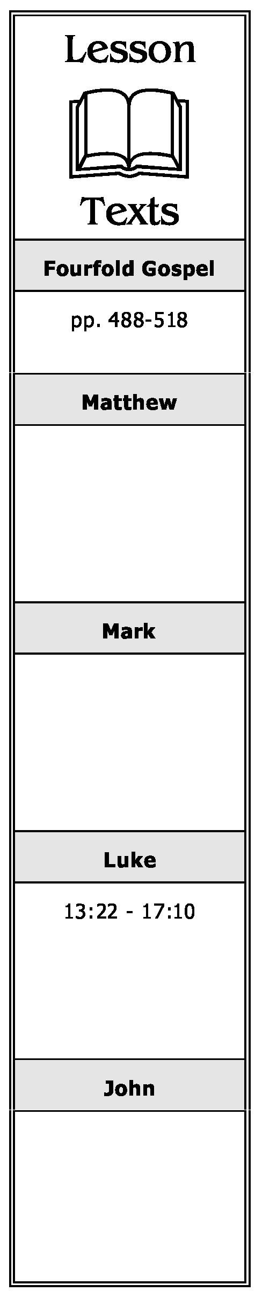

1. What question prompted Jesus' teaching on the narrow or strait gate? What is the main lesson of this teaching?
2. What warning was given to Jesus? What was His response?

**Dining with a Pharisee, Sabbath Healing and Three Lessons Suggested by the Event (Luke 14:1-24)**

1. What response did Jesus get from the lawyers and Pharisees when He asked them if it were lawful to heal on the Sabbath? What did Jesus do as a result of their response?
2. In the parable taught to those He observed choosing the *"chief"* rooms (NKJV: *"best places"),* what did Jesus suggest they do when invited to a wedding?
3. What suggestion did Jesus make to His host in reference to inviting others to dinner?
4. In the parable of the great supper, what excuses were offered for not being able to accept the invitation? What is the main lesson of the parable?

**Cost of Discipleship Must Be Counted (Luke 14:25-35)**

1. Whom did Jesus say one must *"hate"* (love less) if he is to be His disciple?
2. What two examples did Jesus use to teach that one needs to *"count the cost"* before becoming His disciple?

**A Chronological Study of the Life of Jesus Gene Taylor 43**

**The Parables of the Lost Sheep, Lost Coin, and Lost Son (Luke 15:1-32)**

1. What group of people criticized Jesus for allowing publicans and sinners to come near Him to hear His teaching?
2. In responding to the above criticism, what parable did Jesus teach? What is its main lesson?
3. What did Jesus say causes *"joy in heaven?"*
4. What is the main lesson of the lost coin?
5. Briefly summarize the parable of the lost son. What is its main lesson?
6. Compare and contrast the teachings of the three parables in Luke 15.

**The Parable of the Unrighteous Steward (Luke 16:1-18)**

1. In the parable of the unjust steward, how did the steward prepare for his future after being told he would no longer be a steward? What is the main lesson of this parable?
2. Can one serve both God and *"mammon?"* Explain.
3. Why and how did the Pharisees try to justify themselves? What does Jesus teach in response to their derision of Him?

**The Rich Man and Lazarus (Luke 16:19-31)**

1. Compare the respective conditions of Lazarus and the rich man while they lived? What were their status after they died?
2. What request did the rich man make of Abraham? Of what did Abraham remind him? What other reason did Abraham give for not granting his request?
3. After his first request was refused, what did the rich man then request? How did Abraham reply?

**A Chronological Study of the Life of Jesus Gene Taylor 44**

**Concerning Offenses, Faith, and Service (Luke 17:1-10)**

1. What is an *"offense"* as used in this text? How is it *"impossible"* for offenses not to occur?
2. What in the text indicates the seriousness of offending a *"little one"* and causing him to stumble?
3. What should be the Christian's attitude and action toward his brother who sins against him?
4. What request did His apostles make after Jesus taught them the lesson on forgiveness? Why do you think they made such a request? What was Jesus' response to their request?
5. Explain what Jesus meant when He said, *"So likewise you, when you have done all those things which are commanded, say, 'We are unprofitable servants. We have done what was our duty to do."*

**A Chronological Study of the Life of Jesus Gene Taylor 45**